# A Multifactor Security Protocol for Wireless

# Payment-Secure Web Authentication using Mobile

# Devices

1. Challa Venkata Pranith, 2. Valiveti Lohya Sujith, 3. Kolli Sai Kiran,

4. Pulivarthi Goutham, 5. Dr.K.V.D.Kiran

*1,2,3,4,Department of Computer Science Engineering, IV/IV B.Tech,CSE Students,*

*Koneru Lakshmaiah Education Foundation, India.*

[*pranithchalla@gmail.com*](mailto:pranithchalla@gmail.com)*,* [*lohyasujith1520@gmail.com*](mailto:lohyasujith1520@gmail.com)*,* [*170031068@kluniversity.in*](mailto:kollisaikiran007@gmail.com)*,* [*kollisaikiran007@gmail.com*](mailto:kollisaikiran007@gmail.com)

***Abstract***

*The way we live has been reformed by SmartPhones. Cell phones and PDAs have been packed with ubiquity to a great extent and consumers have now started webbased banking, webbased item purchasing and other online administrations. Either the site or the remote flexible channel has been used autonomously by previous web access authentication systems to confirm the personality of faroff clients. To get to the latest online administrations reliably needs a username and secret phrase to verify the client personality.*

*This is a major weakness because the hidden word can be compromised and later used by the man in the center attack to make illegal entry to the record of the client. We are likely to make a validation system based on a multi-faceted verification method that is both reliable and deeply accessible.* *It features a proprietary way to deal with rendering a validation system based on spasms (Exchange Recognizable proof code) and SMS (Short Message Administration) in order to enable the conventional Login/secret phrase framework to get an additional security level. In addition, we use an encryption method which depends on a symmetric key and an idea of an iterated block figure.* *This idea has been used to retain Spasms on PDAs/PDAs as a mystery code but is also used to start secure web transfers using mobile phones/PDAs. Finally, we extend the two-way validation framework that confirms the two players (client and e-specialist organization). A definite threat analysis shows that the proposed system is safe from various types of web attacks such as phishing, man-in-the-center, infections and anything similar as outlined above. In this paper we are proposing a new system and a protocol for Secure way of transactions by using Multifactor Authentication System.*

**Keywords:**

TIC(transaction identification code), Multifactor, Online transaction/payments, Authentication, Customer Agent (CA),Customer Bank (CB),Customer Bank Authentication Server (CBAS), Merchant Bank (MB),Merchant Agent (MA).

**Introduction**

As registering become imminent, individuals are progressively relying on the Internet to use their enterprise over the Internet. The Web is generally a preferable choice for online services such as internet enterprise, e-casting a ballot, e-banking e-government, and soon something close to that... Online applications need a defensive tackle highlight to ensure confidential customer information. Protection is an important factor in the online payment system focused on the web. There are numerous network vulnerabilities affecting web protection arrangements and growing electronic sharing hazards. The majority of the verification system relies on passwords, individual identifying evidence numbers and keys to navigate their own record data. This sort of verification framework doesn't really verify or validate the character of the customers that the person in question claims to consistently meet the current electronic administrations requires a username and secret key are done to verify the character of the client. This is a big flaw as the hidden word can even be hacked by the man in the center attack later used to make illegal admission to the client's record.

With regard to communications, classified information protection has consistently been an important issue. With equipment advancements that give customers the advantage of transparency used in mobile phones, individuals are currently investing more and more energy in these gadgets. In addition, with the viral popularity of web-based media applications and single sign-on, customers generally do not escape varying potential risks with their data. Multifactor Authentication makes more and shifted dividers to shut out some unacceptable individuals from seeing your data

What is Single-factor Authentication (SFA):

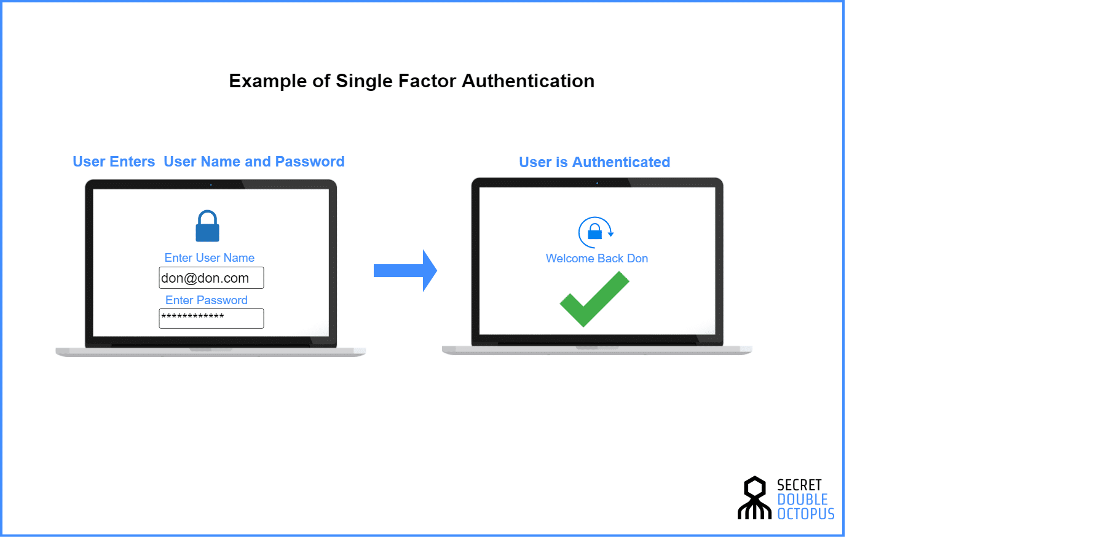

Figure 1: Single-factor Authentication

The most straightforward sort of confirmation strategy is single-factor authentication. A individual matches one credential with the SFA to verify himself or herself online. A password to a username will be the best known example of this. Today, most verification utilizes this kind of verification methodology.

What is Two-factor Authentication (2FA):

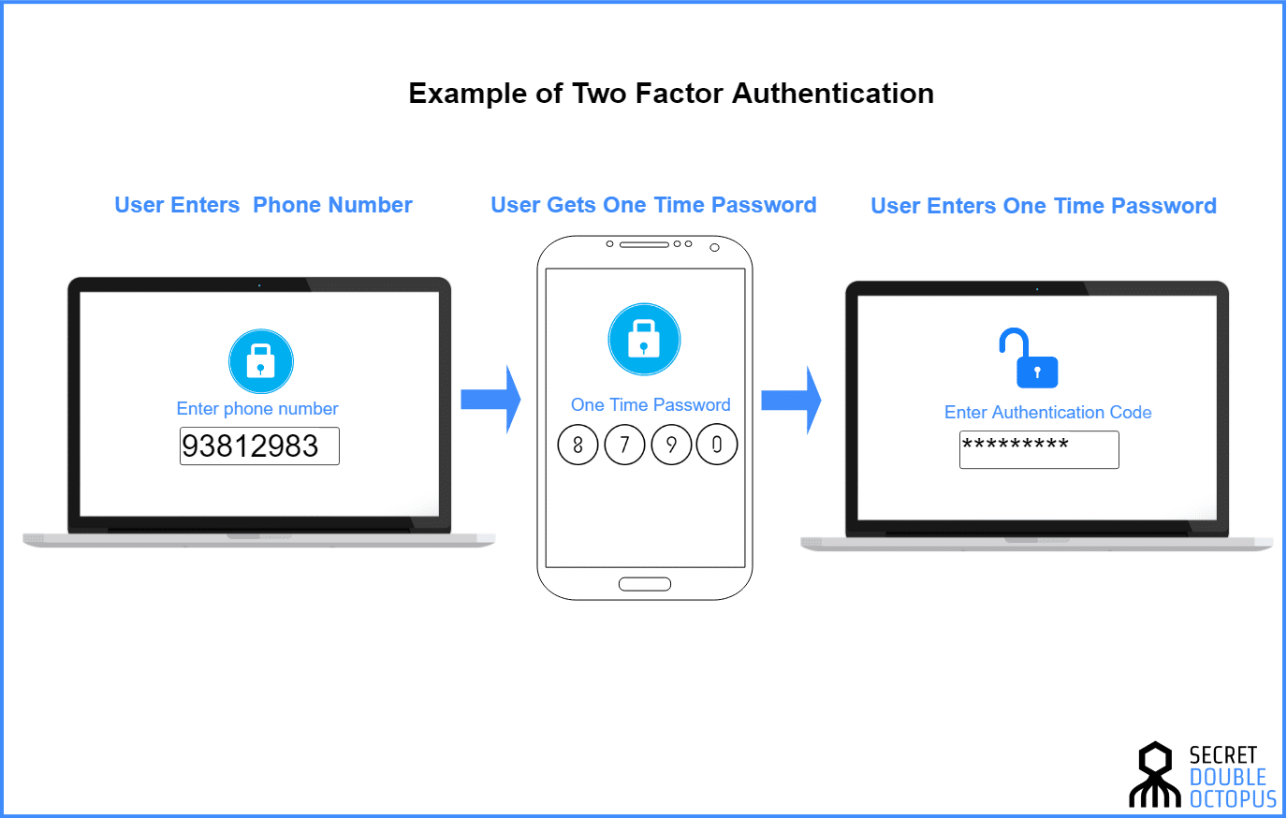

Figure 2: Two-factor Authentication

Two-factor authentication uses the same combination of password/username, but with the addition of being asked to verify who a person is, such as a mobile device, using only something he or she owns. Getting straight: utilizing 2 factors to validate an identity

What is Multi-factor Authentication (MFA):

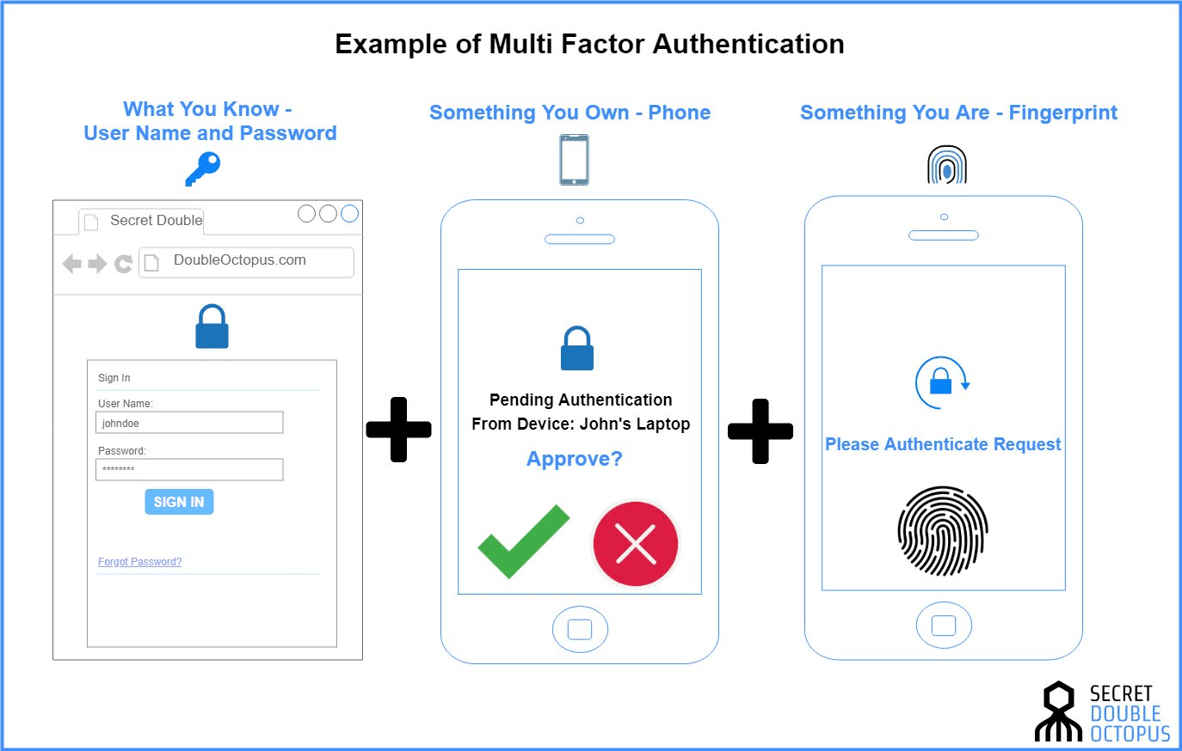

Figure 3: Multi-factor Authentication

A combination of the inclusion procedures is used for Multi-factor Authentication: something you know, something you have and something you are. The 2FA is an MFA subset.

**Literature Survey**

Asoke Nath [1] in 2016 have gave an issues and challenges faced in two factor authentication system as fake websites provide would-be hackers a way of getting personal information from individuals. The “store-front” looks authentic, and the user ends up entering information like credit card numbers, social security numbers and bank account information directly into the hands of an identify thief. Another type of security breech is if the would-be hacker already has access the computer itself. Then when the user accesses either company or internet resources, the attacker then attempts to piggyback on the transmission and either perform fraudulent transactions, or access secure resources.

In 2017, Kumar Abhishek and Prabhat Kumar[2] presented a report on multifactor authentication schemes as new problems and opportunities for new authentication systems and protocols have been unleashed by the advancement of technology. Authentication ensures that who they pretend to be is a consumer. As more factors are involved in the verification process, esteem in authenticity increases exponentially.

The preferred use and interpretation of multifactor authentication that should be used by existing systems was given by Rajeev Ranjan[1] in 2017. It is referred to as Strong Authentication or Multifactor Authentication when the security infrastructure uses two or more distinct and distinct types of authentication mechanisms to protect the wellbeing of valid authentication. In order to provide stronger remote authentication than standard, weak single-factor username and password authentication, multifactor authentication uses combinations of “Something you know," "Something you have," "Something you are”.

In 2018, Aleksandr Ometov, Sergey Bezzateev, Sergey Andreev[3] proposed the challenges faced in managing the MFA as the recognition of users is a crucial element for the adoption of strong identity and authentication by different factors. It is important to follow a cautious and thorough approach when embracing and deploying MFA solutions, where most problems arise from opportunities and potential benefits.

# Existing System

Mobile Payment (M-payment) is a wireless payment system that has drawn researchers' interest in recent years. M-Commerce payments can be made in many forms and are based on the paradigm of anywhere, anytime." In M-commerce or E-commerce applications, m-payment is a critical component. M-payment on a mobile device will be very common and provide immense potential for M-commerce in the coming years, according to the worldwide forum. In recent years, the Safe Wireless payment system has become an important field of study. For Internet-based commerce, there are different types of electronic payment solutions available. Mobile payment means M-wireless-based commerce's electronic payment to facilitate point-of-sale/point-of-service (POS) payment transactions using mobile devices such as mobile phones, tablets and personal digital assistants (PDAs) or mobile terminals.

In general, in order to process and sustain m-payment transactions based on wireless commerce applications, M-payment methods are normally used by vendors to make wireless payments, content providers, and information and service providers. The current m-payment schemes can be categorized into three key groups, as discussed in

- Payment mechanisms focused on accounts,

- Payment system for mobile POS,

-E-cash or E-wallets.

Therefore in order to improve more and more reliable protection for online payments, we have proposed a new multi-factor authentication protocol.

**Proposed System**

1. Multifactor Authentication*:*

For high-risk transactions requiring access to consumer information or the transfer of funds to other parties, single-factor authentication is insufficient. Multi factor authentication methods need to be used to provide secure online transactions using mobile phones. We use multi factor authentication in our scheme, using two different modes. TIC and SMS are used to execute the execution. Although in previous approaches to the issue, SMS was used. We are incorporating the latest definition of TIC as a novel method of authenticating a transaction and the user to previous approaches to the problem. Authentication of the TIC (Transaction Identification Code) is the technique used to identify both the recipient and the ongoing transaction. The TIC code certifies that the correct person has initiated the current transaction and is a legitimate user attempting to access his/her account.

Codes for TICs are:

*Issued to the consumer by a bank or financial institution.

*8 bit or 16 bit Pseudo-randomly generated code assigned to the clients.

*Complicated sequences of digits or combinations of binary or alpha numeric characters may be possible.

*Only one TIC code is used once, i.e. a special TIC for each transaction is used.

Here, we presume that financial institutions are responsible for confidentially storing the logic and algorithm of TIC generation and have their standarized to determine the complexity of the TIC format. Financial institutions are also responsible for updating the logic and data for the TIC generation from time to time and also for maintaining it completely secret. As needed, the consumer will receive a list of TIC codes from the bank or financial institution.

During an online web transaction, the bank or financial institution will make a register of the given TIC codes for its customers and match the same code. After each good transaction, a TIC code is cancelled. According to issuing organizational policies, we can also settle on a validity period of TICs, which incorporates an enhanced security functions of the system.

## Protocol:

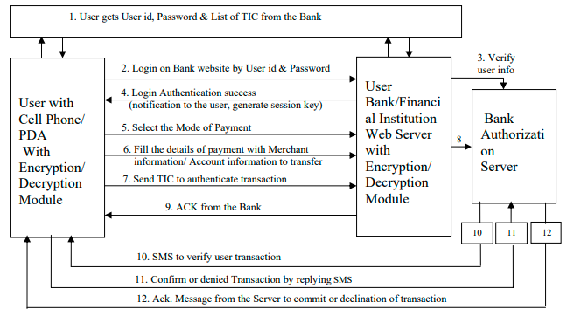

Figure 4: Protocol for wireless payment: Multifactor secure Web authentication protocol using mobile devices

Protocol Flow Steps:

1. The customer gets the bank's username/password and transaction identifier codes (TICs). Each user has only one username/password in their account, but for each online transaction, the TIC code is unique. Users can obtain a list of TIC codes according to their specifications from the bank authority or authorized financial institution.
2. Basic authentication of a Webbased username/password is used to identify the user to the Web server.
3. A Bank Authentication Server can validate the username and password. The user will get a choice screen after user acknowledgement to proceed further.
4. The user will be notified of an effective logging phase with a welcome message. A session key is also produced by this phase.
5. The user selects the payment mode. Two payment methods were considered: the system based on credit cards & the electronic transfer based on accounts. Adding other modes to our device is straightforward.
6. By filling in a simple form with details such as merchant bank and branch code information, invoice number and account number to which an amount must be transferred, the user can insert the payment details.
7. By simply choosing a TIC code from the stored list of TICs, the user can insert a TIC code. Note that TICs are stored with local encryption on the mobile phone, with password protection. In addition to provide unique authentication to each web transaction, the user will decrypt and insert the TIC into the financial transaction. All transaction data, with the TIC attached, will be further encrypted by the AES encryption technique and sent to the web server of the bank. It would be forwarded to the authentication server by the bank web server where it would be decrypted and matched with the list of TICs that were provided to the customer. Discussions on the method of encryption/decryption used in the proposed scheme .
8. The server for bank authorization decrypts the message received and extracts the TIC. It then tests the TIC received from the user by comparing it with the TIC list stored on the database server in the user account information. It cancels the used TIC from its database if both TICs match, and goes to the next stage. If no TIC matches those in the database, the authentication server denies the transaction to the user and displays an error message to the user.
9. The bank server creates a user recognition that allows the user to log out of the web portal free of charge and wait for a confirmation SMS or to initiate another financial web transaction.
10. After the database update for the ongoing transaction is completed, the authentication server will send an SMS to the cell phone of the user to check the initiated web transaction. The user's cellular phone number is available on the authentication server.
11. By selecting "YES" or by choosing "NO by replying to the confirmation SMS, the user can validate their initiated transaction.
12. The server will notify the user of the successful completion of the transaction or refusal of the transaction through a message.

Therefore here the total flow of execution is segregated into 4 main parts as follows,

Part 1: First Authentication of User to the Bank Authentication Server

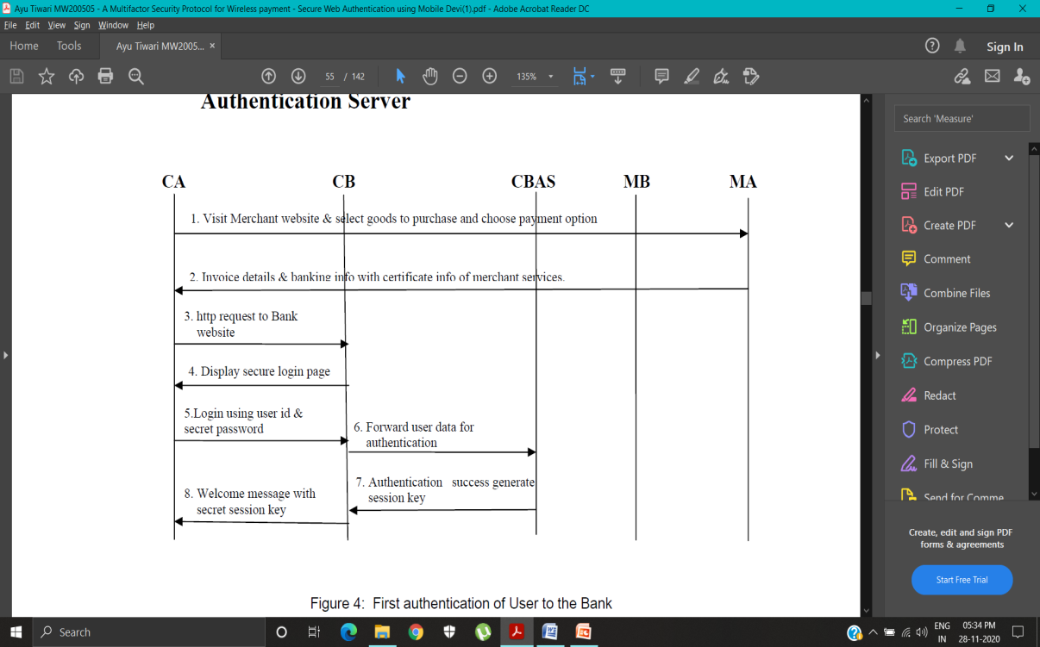

Figure 5: First authentication of User to the Bank

Two-way authentications take place after the first user authentication through login has been completed successfully.

As mentioned in Part-II, the venue.

Part II: Two Way Authentication: Authentication of Merchant to the Customer

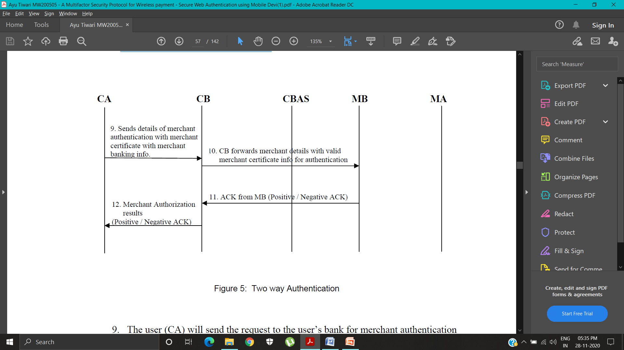

Figure 6: Two way Authentication

As shown in Figure 4, which continues in portion, the multifactor secure web authentication protocol will be run for payment.

Part III: Second Authentication of User to the Bank Authentication Server

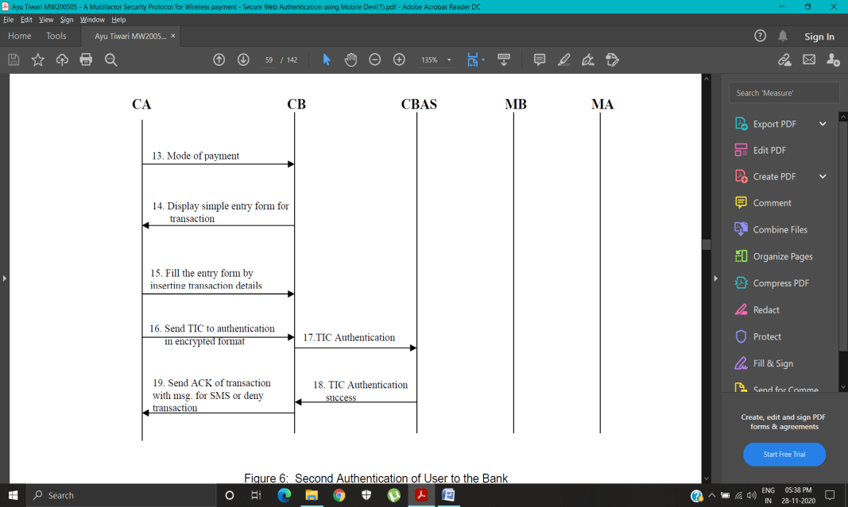

Figure 7: Second Authentication of User to the Bank

The user is free to close the current user session or make new financial transactions after the TIC's successful match. The next step is for authentication server to generate an SMS for the user.

Part IV: Third Authentication of User by SMS confirmation of Web Transaction to the Bank Authentication Server

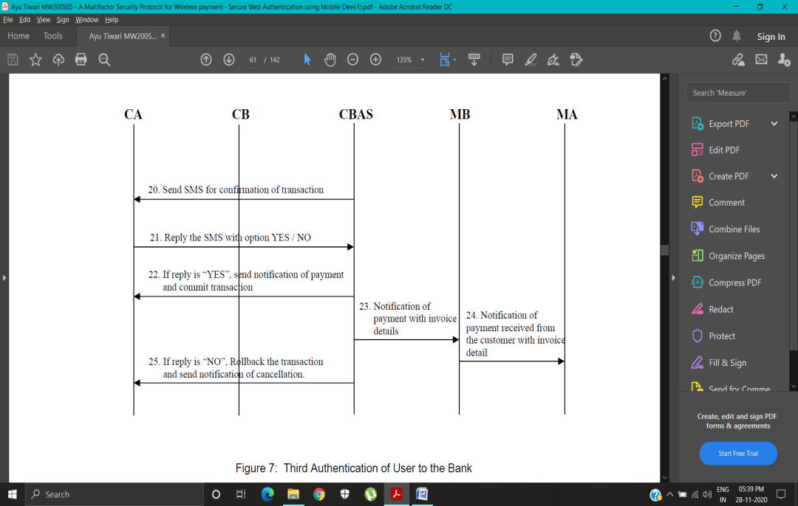

Figure 8: Third Authentication of User to the Bank

The complete transaction flow from client to server is strictly in an encrypted manner to maintain system security and protect confidential data of user.

# Security

Phishing fraud has become a common user identity theft technique. Phisher’s fraudulently captures users' sensitive data such as passwords and credit cards, Information for acquiring unauthorized access to the confidential financial data of the user and carrying out the illicit transfer of funds. Phishing is usually done by email or an instant message or through telephone communication.

The proposed protocol is safe from phishing attacks. A secure user authentication multifactor protocol has the ability to secure user data and preserve malware access integrity, confidentiality and access control. We consider different cases below to grasp the origin of the security.

*Case I: If phisher fraudulently acquires user id and secret password:*

Secret codes issued to legitimate account holders are TIC codes and TICs are not publicly available. For each online transaction, it is a one-time code and it is created in nature randomly so that a phisher can not guess the next user account TIC code.

*Case II: Transmission of TICs over insecure channel:*

The transmission of TIC code from the user's cell phone/PDA to the web authentication server is in a heavily encrypted format, so it can not be easily decrypted by phishing attackers to access private user information on the server side. In addition, only once is one TIC used and then discarded.

*Case III: If phisher fraudulently acquires user’s secret password and also one TIC code by some phishing attack:*

The TIC codes are psuedo random in nature, even if a phishing attacker receives a sample of TIC code from any phishing technique, the phisher will not produce the next TIC code because the logic of TIC generation is strictly confidential on the web authentication server and we believe that banks and financial institutions are responsible for updating TIC generation data from time to time and updating TIC generation.

**Conclusion**

The current validation protocol for online framework implementation is not to ensure that customers are safe from wholesale fraud, as the effect is that any aggressor gains entry into confidential customer data such as Mastercard number or record secret key and allows illegal shop trade that will be charged to the record of the significant customerFor remote installation of the system, we zeroed in on an application-layer security response to conduct a start to finish verification and privacy of information between remote client and java-based protected worker. The introduced work suggested another web client validation convention focused on a multifaceted verification method that is fully safe and easy to execute.

We based on an application-layer protection solution for the presented protocol for Regulation of an end-to-end authentication and data wireless payment system Wireless device confidentiality with java-based secure servers. The work presented is a new web user authentication protocol based on multifactor authentication has been proposed. An approach that is entirely safe and easy to enforce.

Future work will concentrate on creating a modern and reliable way to produce TIC codes.

At the institutions of finance. Installing the TIC code on the mobile phone of the user must also be an

The simple job is to discourage frequent customer visits to the bank or financial institution.

Maintenance, control process and delivery on the server side TIC to fulfill the Demand from a large number of users is also part of potential job prospects.

**References**

1. <https://link.springer.com/chapter/10.1007/978-3-642-31552-7_57>
2. <https://www.researchgate.net/publication/322288752_Multi-Factor_Authentication_A_Survey>
3. <https://www.researchgate.net/publication/292392168_Issues_and_Challenges_in_Two_Factor_Authentication_Algorithms>
4. Adi W., Mabrouk A., Al-Qayedi A., Zahro A. , “Combined Web/Mobile Authentication for Secure Web Access Control”, In Wireless communications andNetworking conference,IEEE Communications Society, Atlanta, GA USA,volume 2, pp. 677- 681, March 2004
5. J. Gao, J. Cai, K. Patel, and S. Shim , “Wireless Payment”, In Proceedings of the Second International Conference on Embedded Software and Systems (ICESS’05),Xian, China, pp. 367-374, December 2005
6. Jerry Gao, Krishnaveni Edunuru, Jacky Cai, and Simon Shim, “P2P-Paid: A Peer-to- Peer Wireless Payment System”, In Proceedings of the Second IEEE International Workshop on Mobile Commerce and Services (WMCS’05), Munich, Germany, pp. 102-111, July 2005.
7. <https://www.cmu.edu/iso/news/mfaarticle.html#:~:text=Multi%2Dfactor%20authentication%20should%20be,protect%20highly%20sensitive%20personal%20information>
8. Ayu Tiwari, Sudip Sanyal, Ajith Abraham, Sugata Sanyal and Svein Knapskog, ”A Multifactor Security Protocol For Wireless Payment-Secure Web Authentication using Mobile Devices”, IADIS International Conference, Applied Computing 2007, Salamanca, Spain, pp. 160-167, February 2007.
9. S. Kungpisdan, B. Srinivasan and P.D. Le, “A Secure Account-Based Mobile Payment Protocol”, In Proceedings of the International Conference on InformationTechnology: Coding and Computing, IEEE CS press, Las Vegas USA, volume 1,pp. 35-39, April 2004.
10. Lawton G., “Moving Java into Mobile Phones”, IEEE Computer, Volume 35 Issue 6, pp. 17- 20, June 2002.